Importing required data

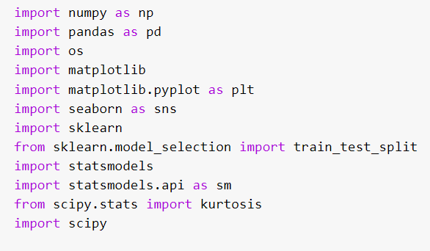

**importing datasets uploaded on the google drive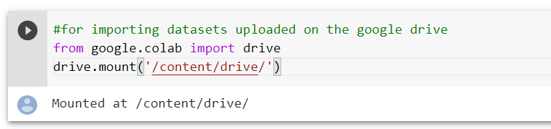view the folder import from the google drive**

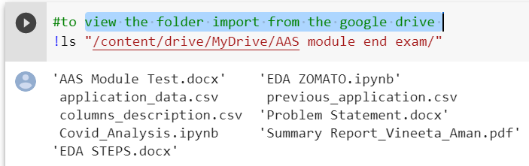**assigning path variable to path of the data sets**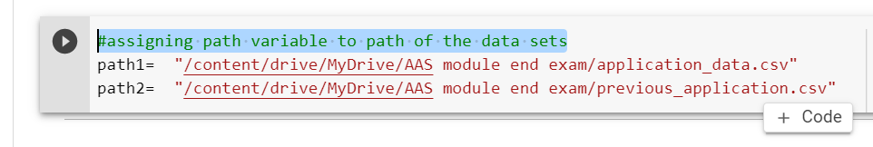

**Importing Data from CSV**

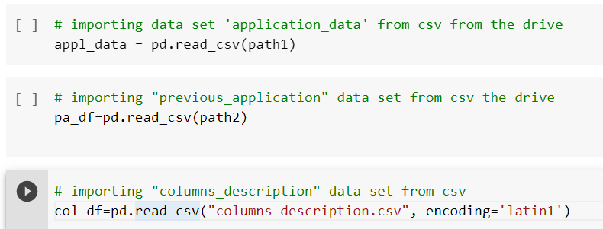

# Viewing the Dataset

checking first five rows and columns of the application_data dataset

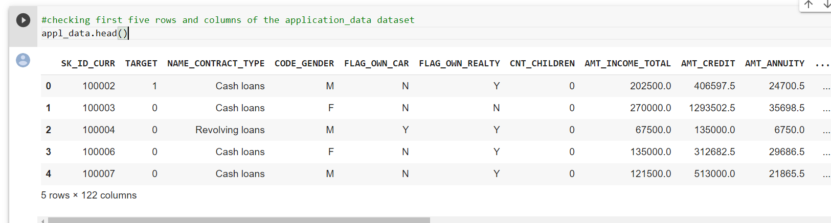

checking first five rows and columns of the previous_application dataset

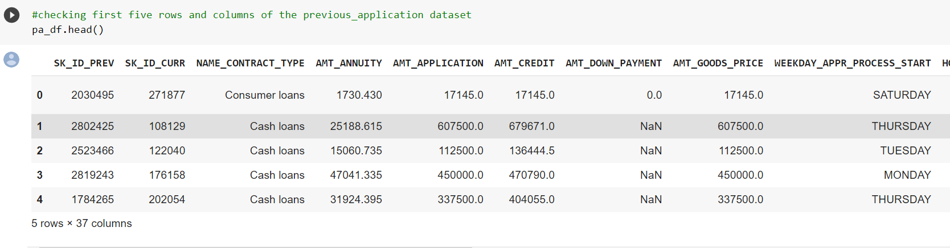

checking first five rows and columns of the columns_description dataset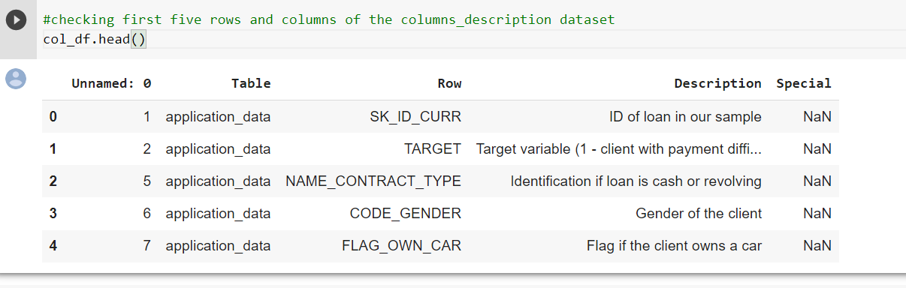

checking the shape of the dataset "application_data"

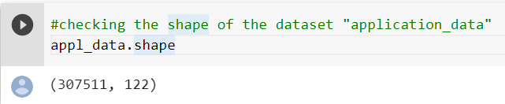

checking the shape of the dataset "previous_application"

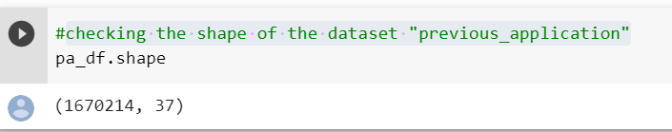

checking the shape of the dataset "columns_description"

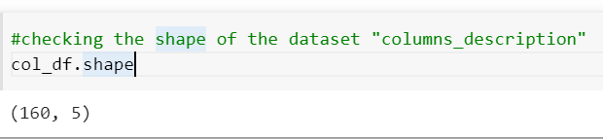

checking the dimension of the "application_data" data set -- We have a two dimension dataset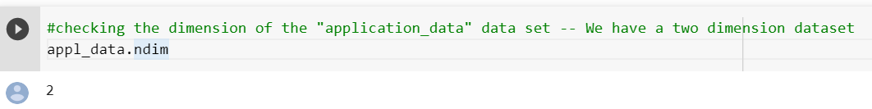

checking the dimension of the "previous_application" data set -- We have a two dimension dataset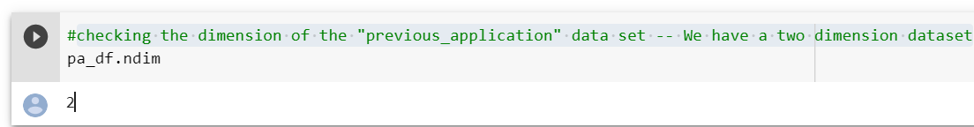

checking last five rows and columns of the raw dataset--"application_data"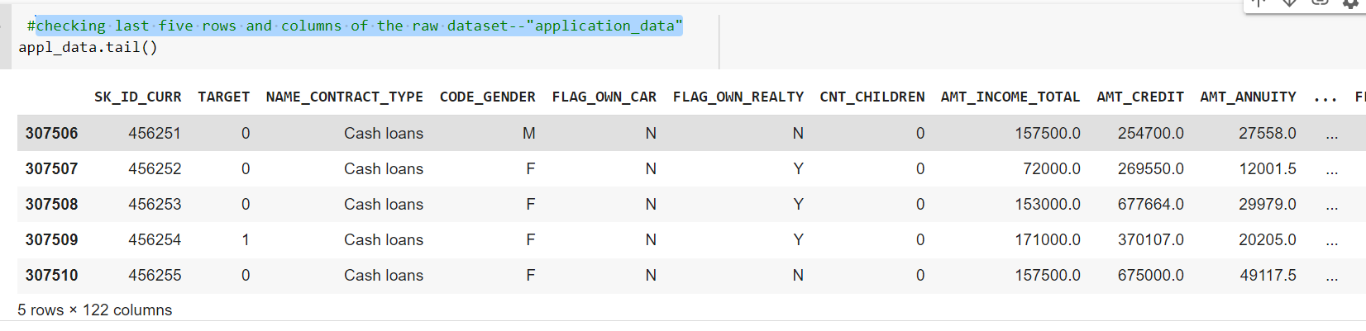checking last five rows and columns of the raw dataset--"previous_data"

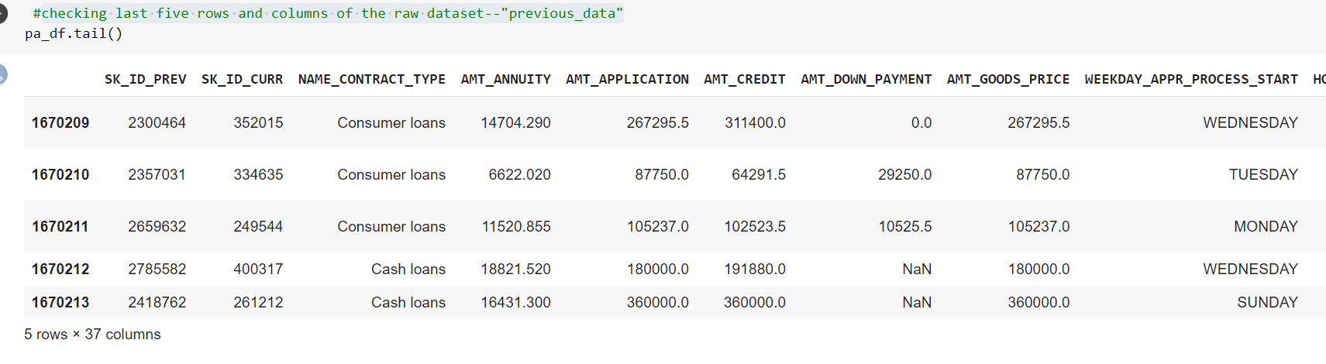

checking the data types of columns of data set "application_data"

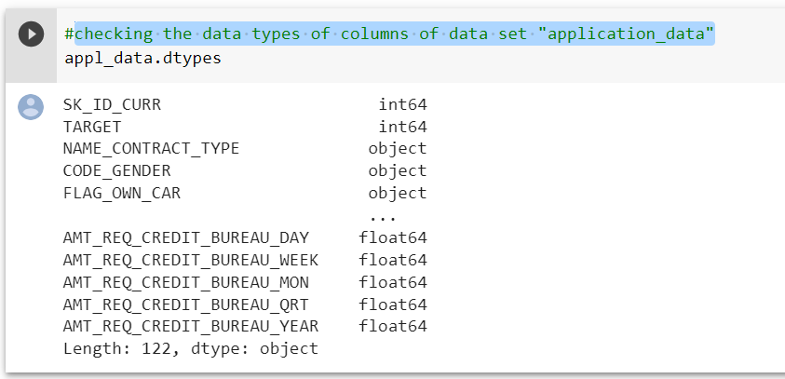

checking the data types of columns of data set "previous_application"

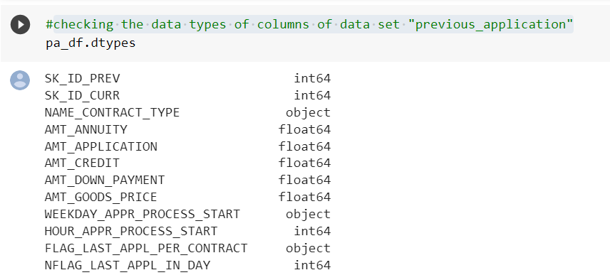

'''it provides purely descriptive information about the dataset.

This information includes statistics that summarize the central tendency of the variable,

their dispersion, the presence of empty values and their shape'''

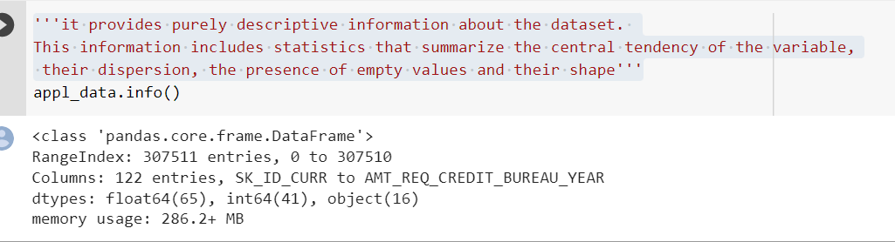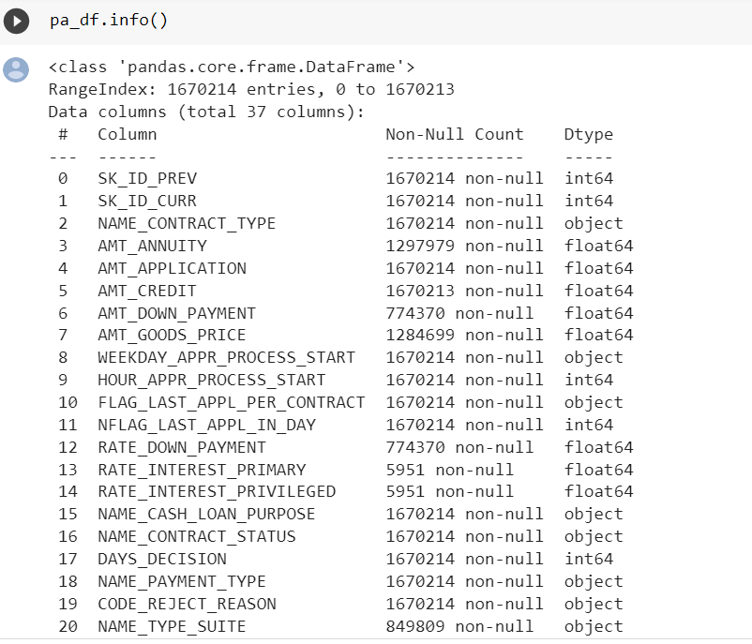This shows the statistical summary of all numeric-typed (int, float) columns

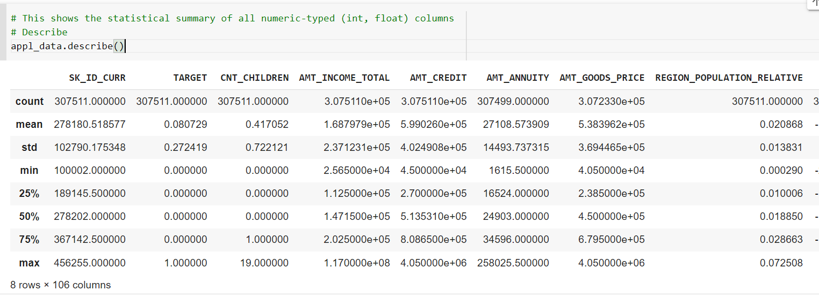

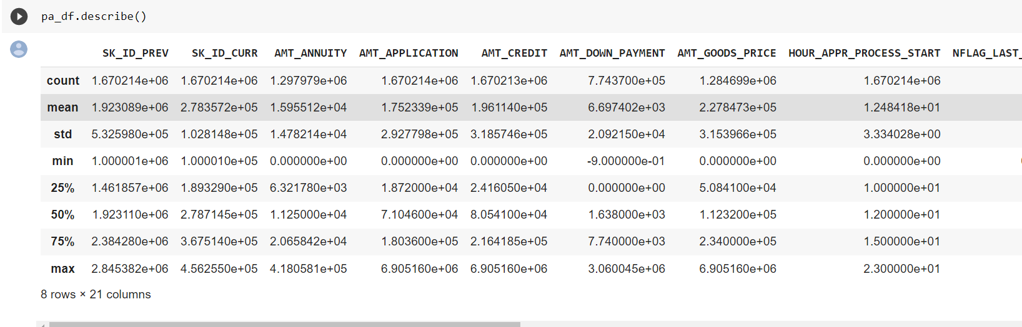 checking all the columns including those that are of type object

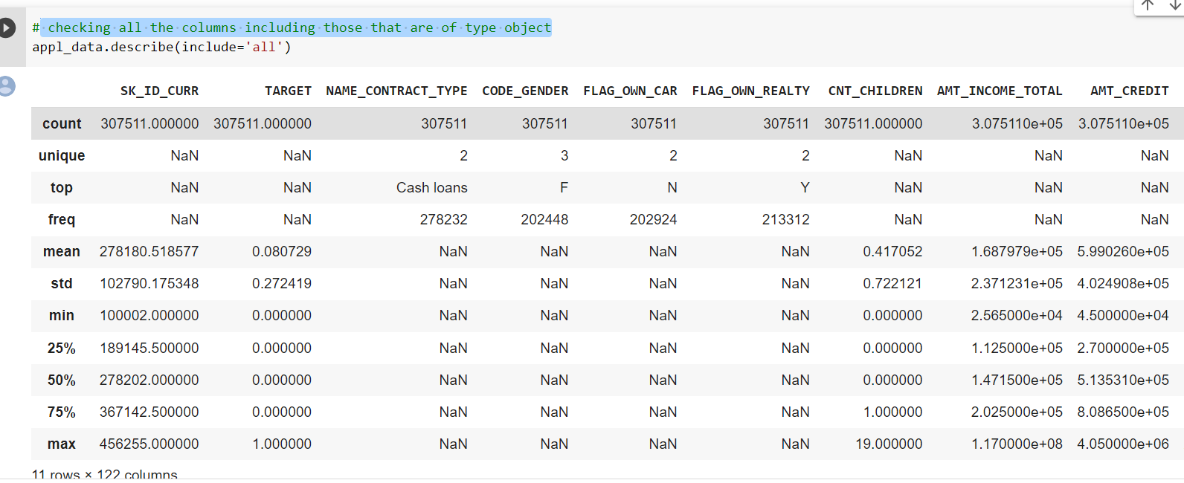

checking all the columns including those that are of type object

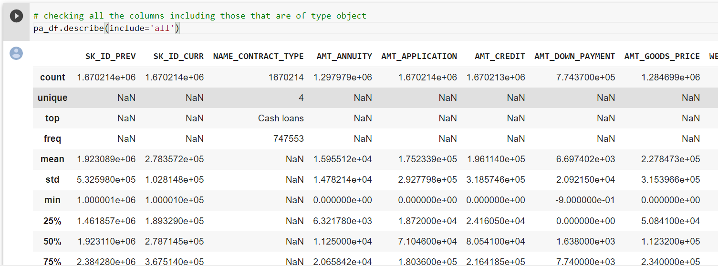

# Data Preparation

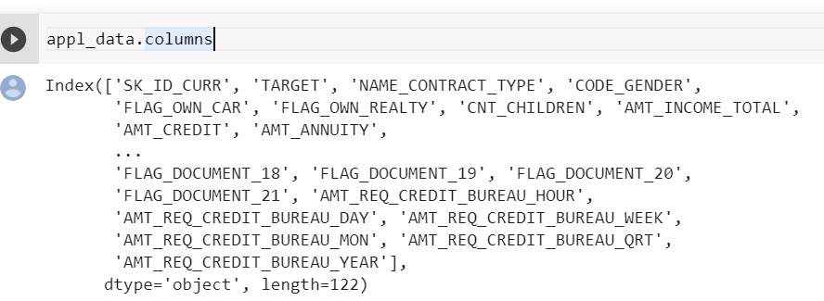As data is having huge number of lines, we are considering applicable columns only by looking at data set

creating a new data set using the columns of appl_data

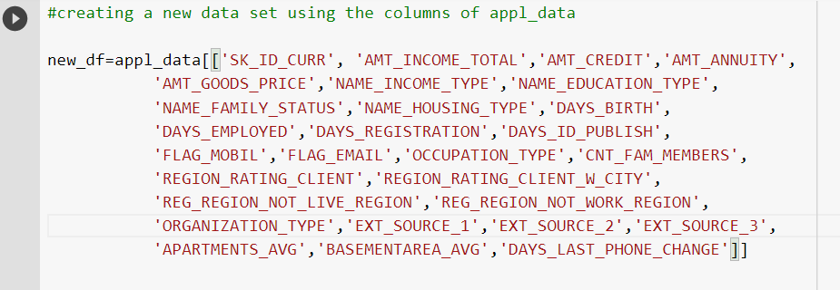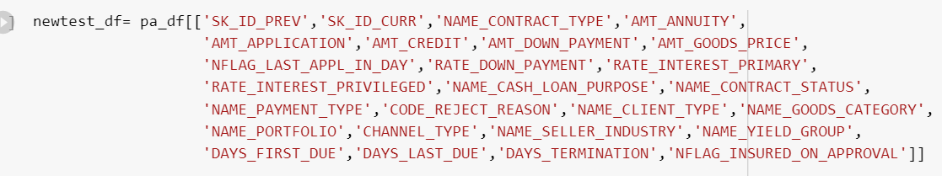

creating a new data set using the columns of pa_df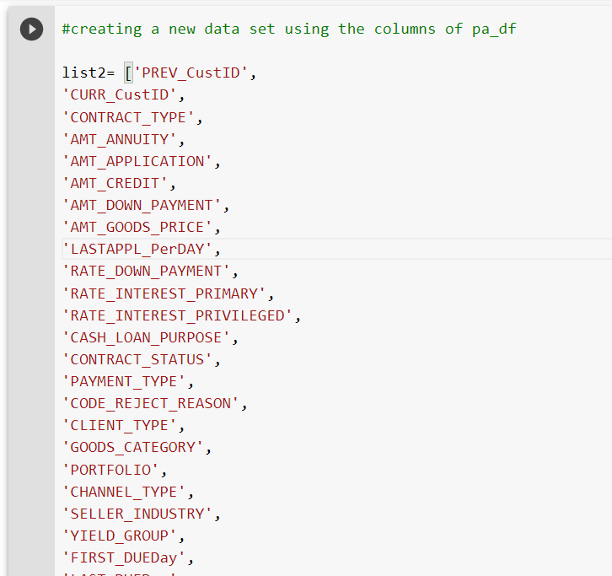

new dataframe created for pa_df -- "previous_application" with change in column names 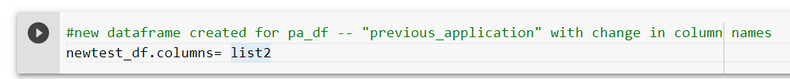

checking if the list2 co

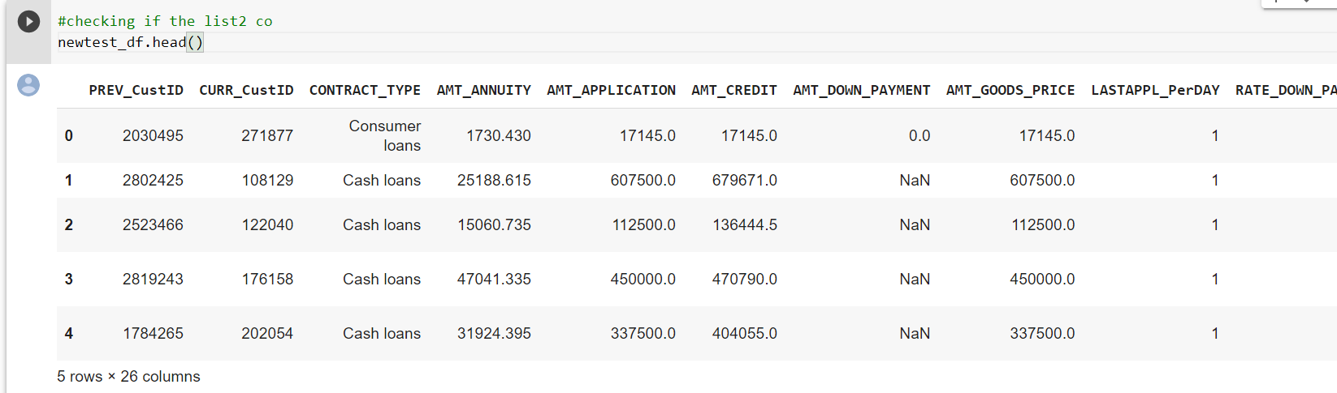checking the new dataframe of appl_data -- "application_data"

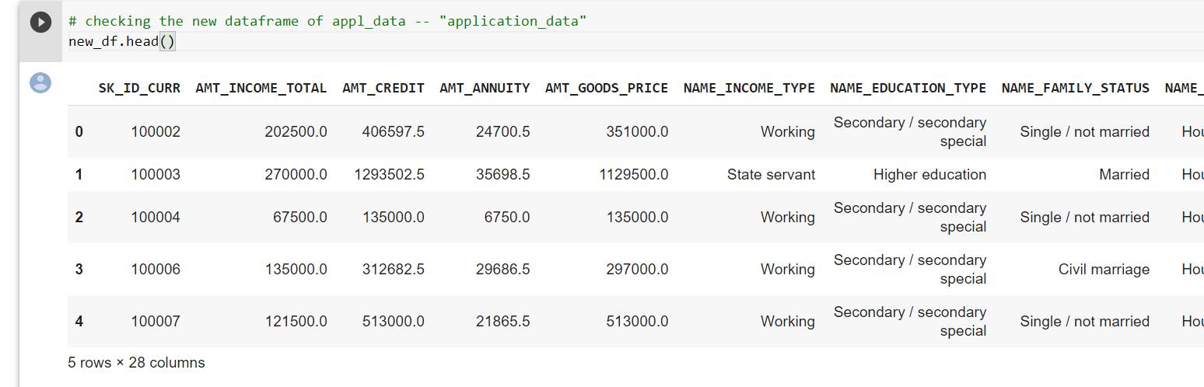checking shape of new data of appl_data , we have now reduced our no of columns from 122 to 28

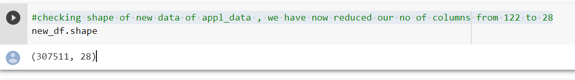

checking names of columns of new data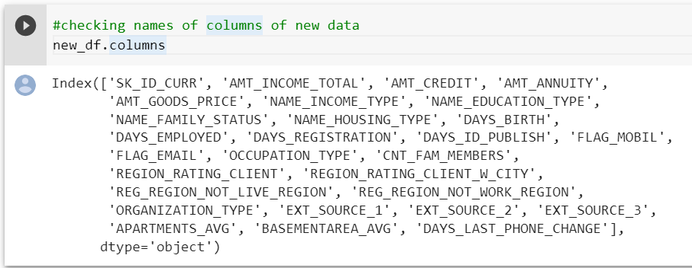renaming the column names

creating a list to rename the columns

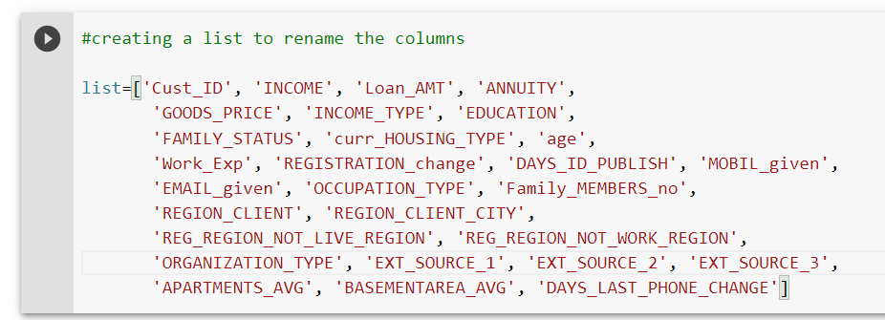

conactenating the list to new_df

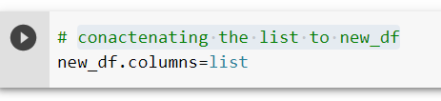

checking if the column names have changed

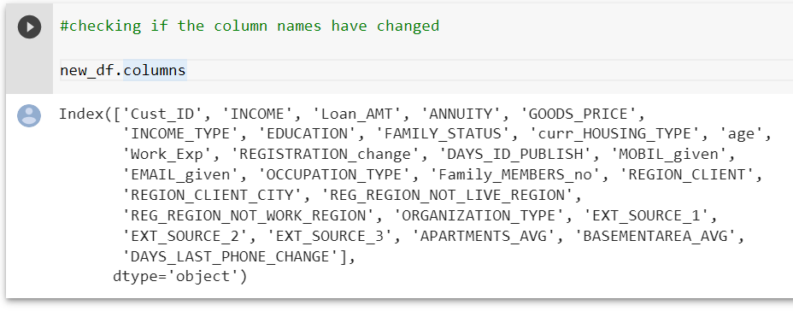

checking for columns with null values

checking how many null values are present in each of the columns

creating a function to find null values for the dataframe appl_data --> application_data

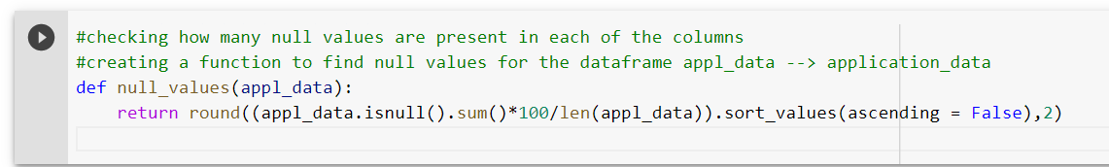

displaying the column names and displaying the percentage of columns having null values

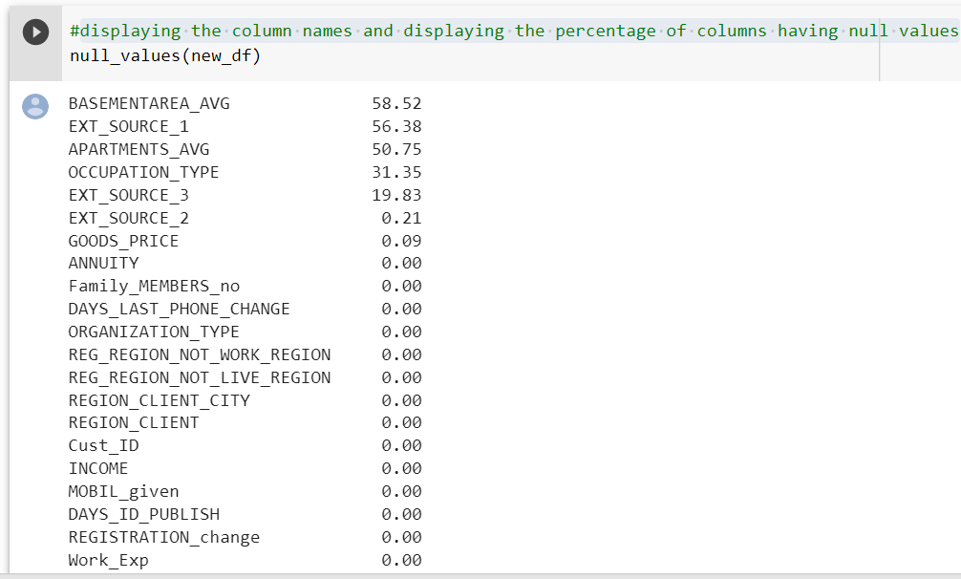

creating a function to find null values for the dataframe appl_data --> previous_data

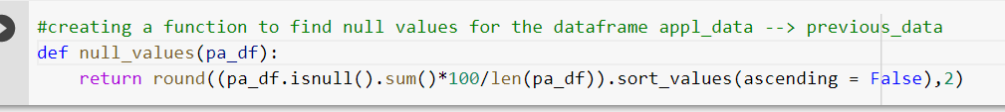

displaying the column names and displaying the percentage of columns having null values in newtest_df

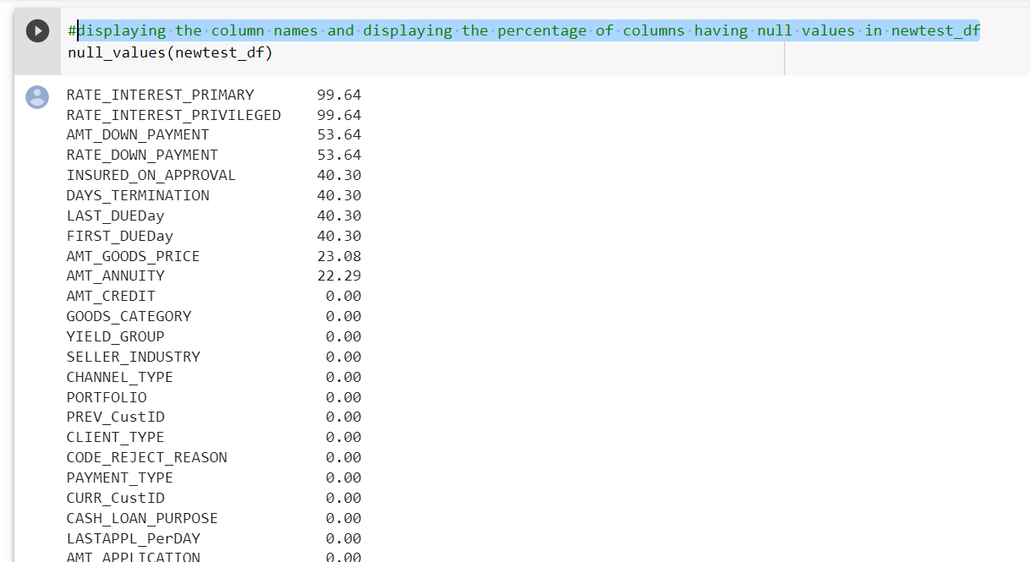

these are the columns having maximum null values

1. RATE_INTEREST_PRIMARY 99.64
2. RATE_INTEREST_PRIVILEGED 99.64
3. AMT_DOWN_PAYMENT 53.64
4. RATE_DOWN_PAYMENT 53.64
5. INSURED_ON_APPROVAL 40.30
6. DAYS_TERMINATION 40.30
7. LAST_DUEDay 40.30
8. FIRST_DUEDay 40.30
9. AMT_GOODS_PRICE 23.08
10. AMT_ANNUITY 22.29

number of null values per column

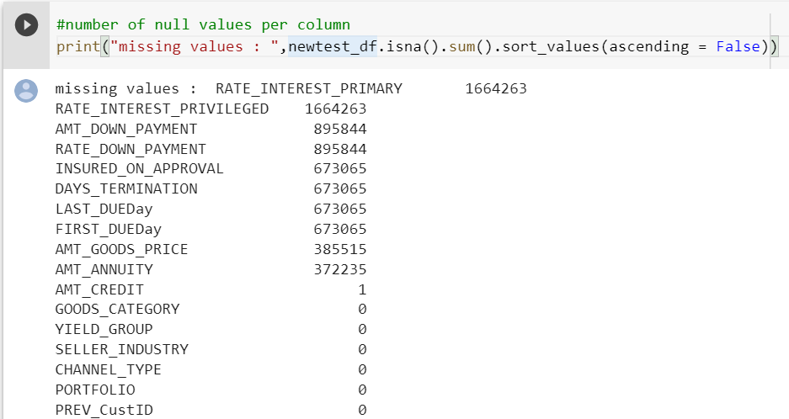

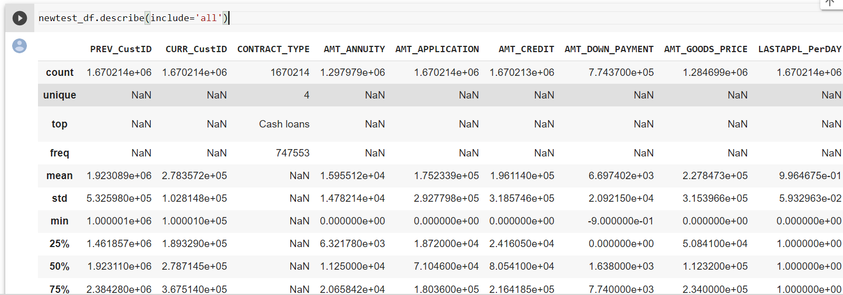

# checking unique values for categorical columns and visualizing data

importing visualization libraries

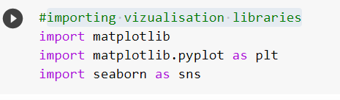

unique value CONTRACT_TYPE

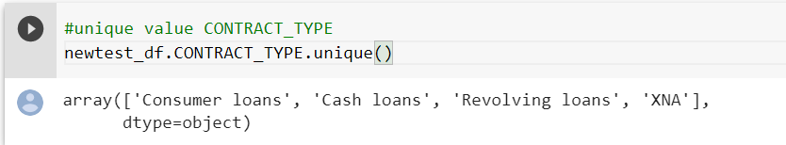

count of unique value CONTRACT_TYPE

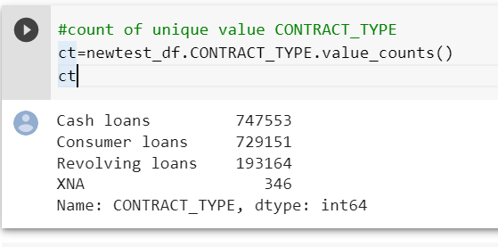

plotting bar chart for CONTRACT_TYPE categorical data

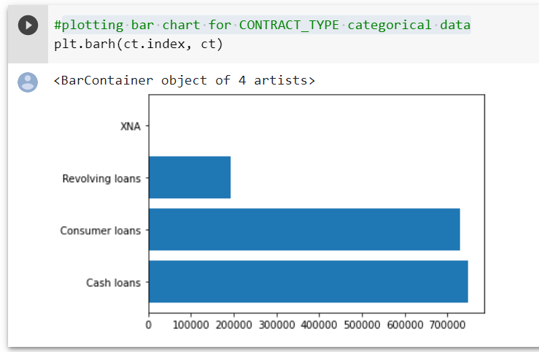

Conclusion:

plot clearly shows that Customer taking cash loans and customer loans are more than compared to those taking revolving loans

plotting pie chart for CONTRACT_TYPE categorical data

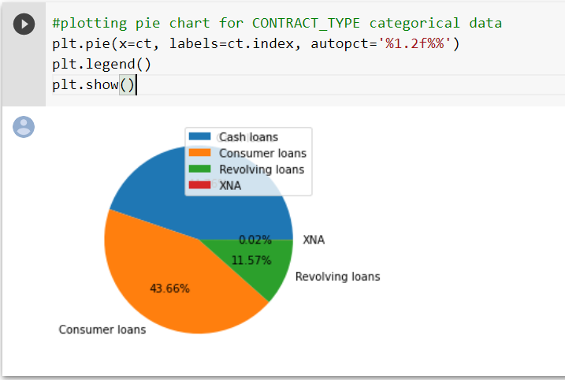

Conclusion:

Client taking cash loan more

unique value CLIENT_TYPE

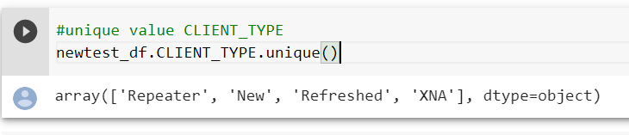

count of unique value CLIENT_TYPE

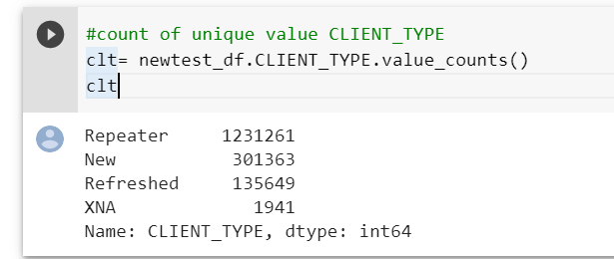

plotting bar chart for categorical data

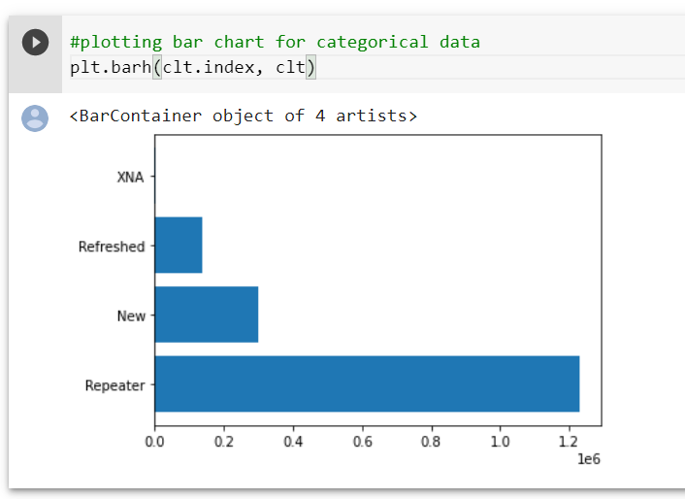

Conclusion:

From bar graph is concluded that clients who are repeater are maximum

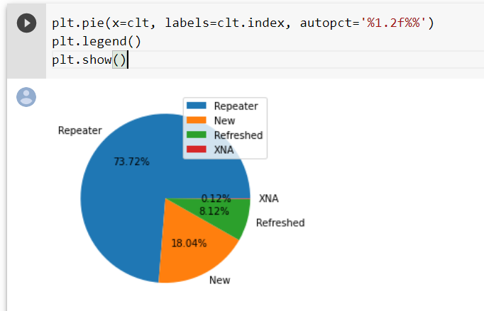

Conclusion:

From pie graph is concluded that clients who are repeater are maximum

unique value GOODS_CATEGORY

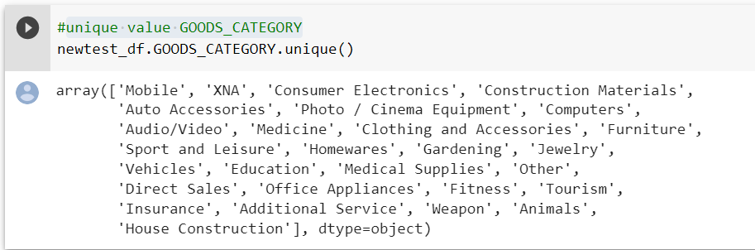count of unique value GOODS_CATEGORY

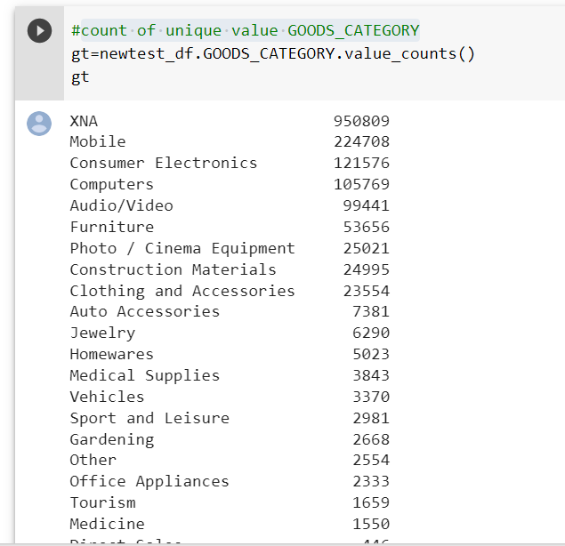

plotting bar chart for GOODS_CATEGORY categorical data

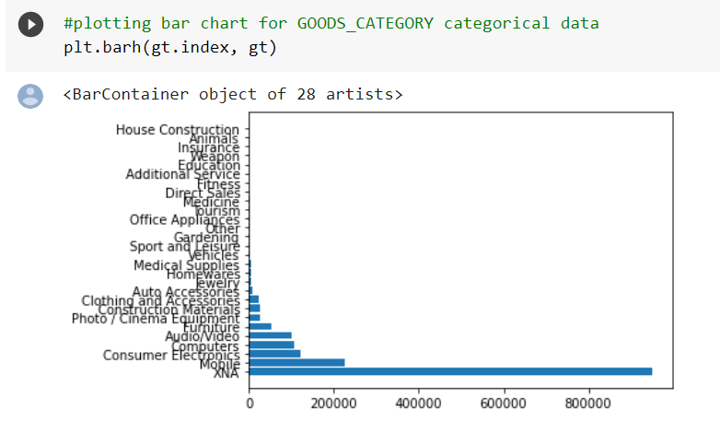

Conclusion:

It can be concluded that clients who are taking loan for goods category of XNA are maximum

plotting pie chart for GOODS_CATEGORY categorical data

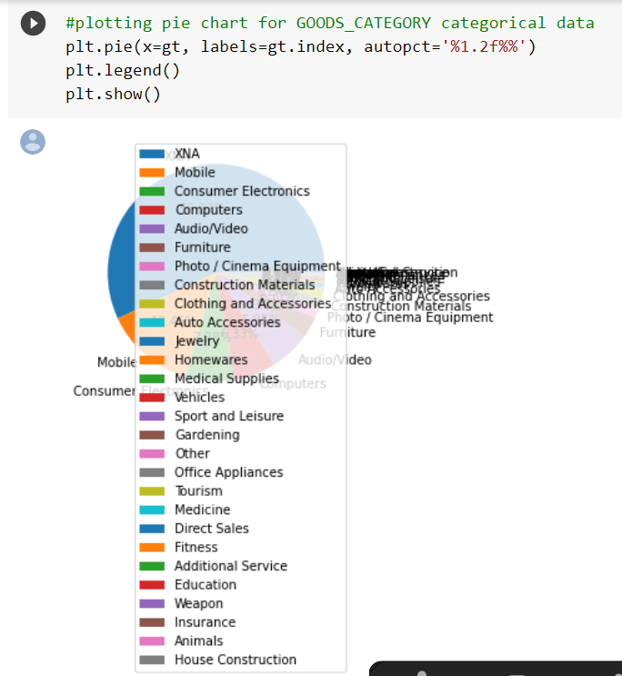

Conclusion:

People taking loans for electronics equipment are more as compared to people taking loans for house construction or insurance.

unique value PORTFOLIO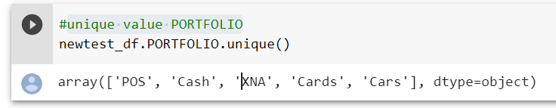count of unique value PORTFOLIO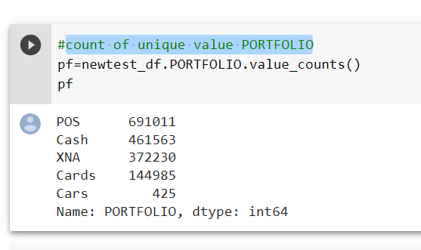

plotting bar chart for PORTFOLIO categorical data

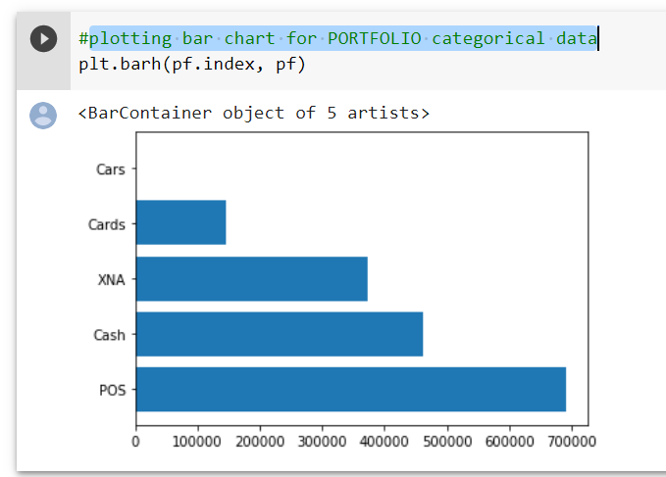

Conclusion:

It is concluded that POS (point-of-sale) type loan category are maximum

POS financing is **a broad term that describes methods for giving shoppers flexible, pay-over-time installment options**.

plotting pie chart for PORTFOLIO categorical data

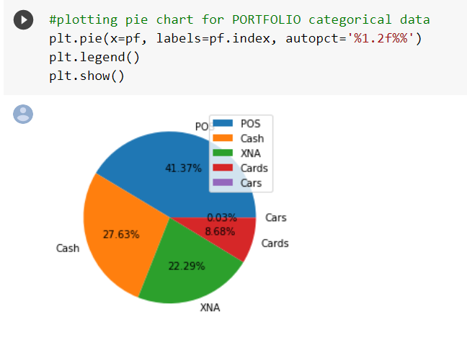

Conclusion:

unique value CHANNEL_TYPE

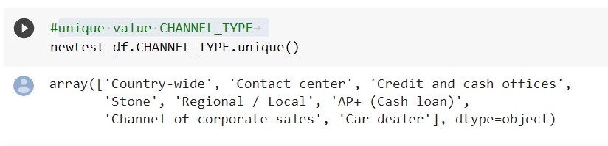count of unique value CHANNEL_TYPE 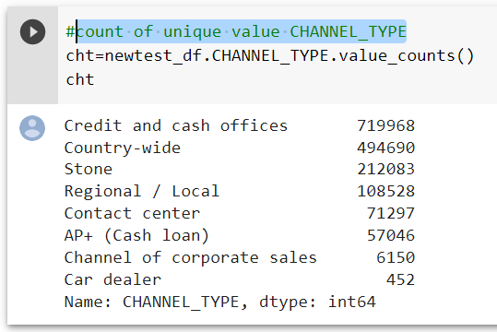

plotting bar chart for CHANNEL_TYPE categorical data

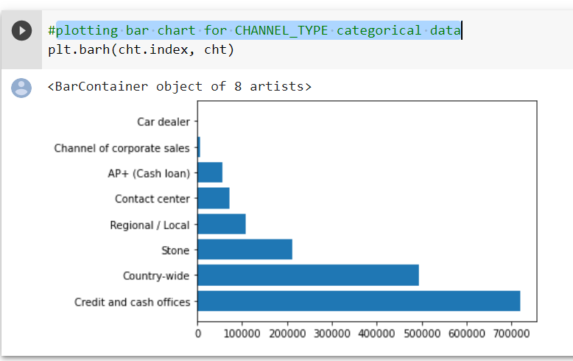

Conclusion:

plotting pie chart for CHANNEL_TYPE categorical data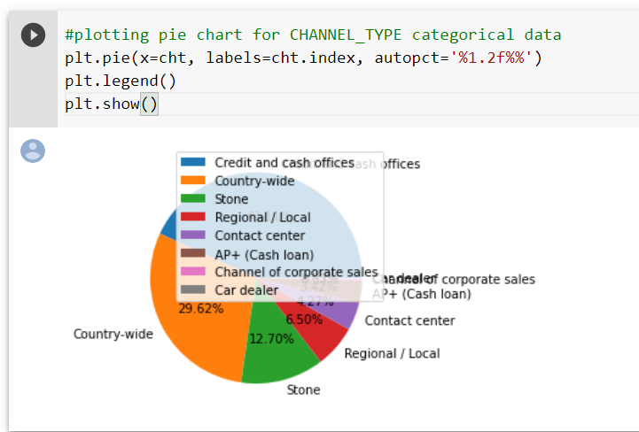

unique value SELLER_INDUSTRY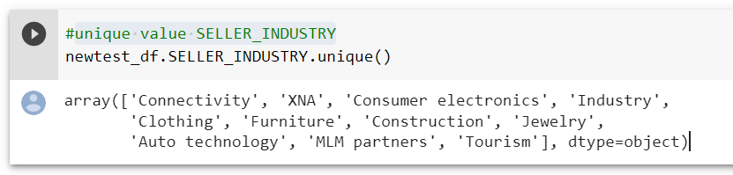

count of unique value SELLER_INDUSTRY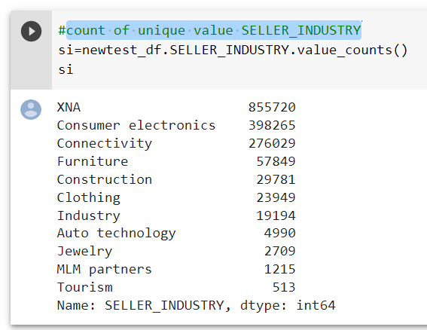

plotting bar chart for SELLER_INDUSTRY categorical data

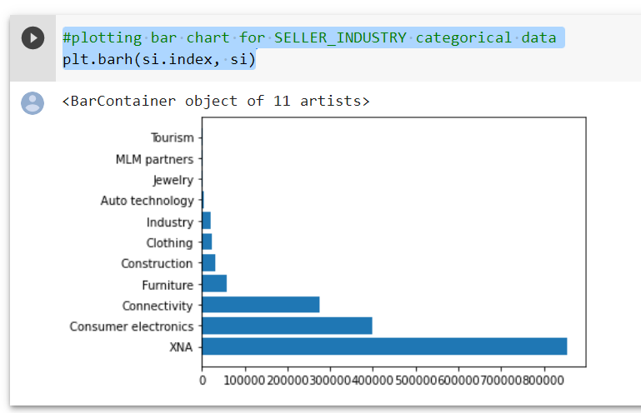

plotting pie chart for SELLER_INDUSTRY categorical data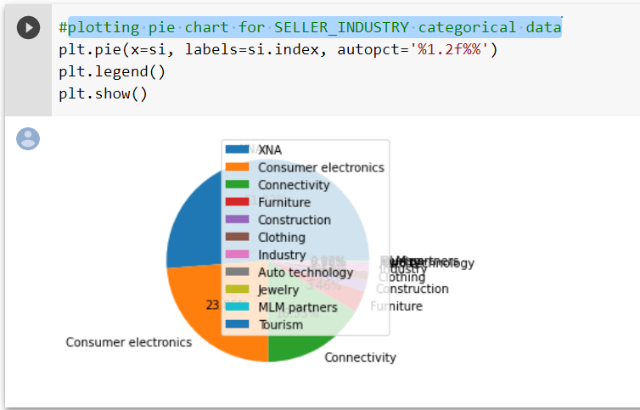

Conclusion:

unique value YIELD_GROUP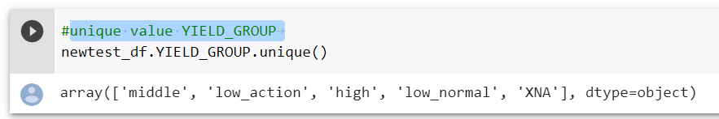

count of unique value YIELD_GROUP 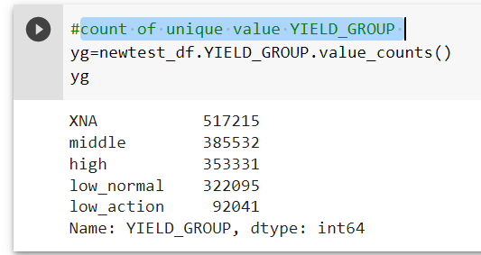

plotting bar chart for YIELD_GROUP categorical data

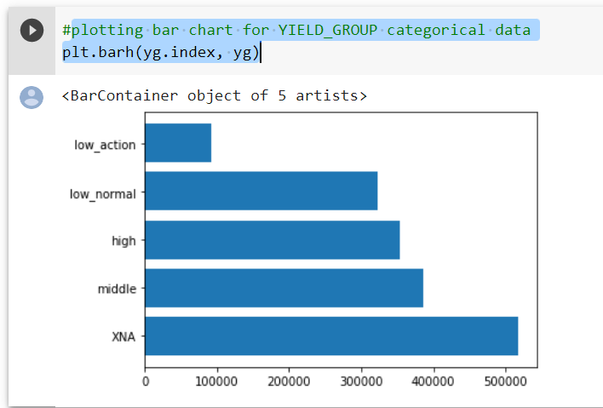

plotting pie chart for YIELD_GROUP categorical data

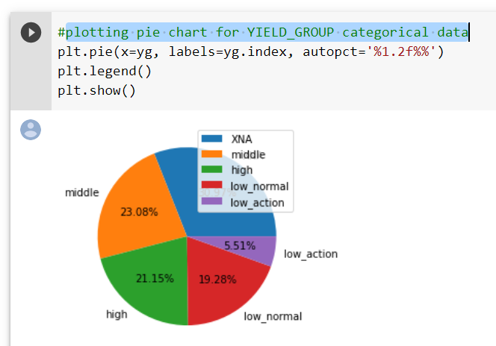

Conclusion:

--> for categorical data

checking the data types of new test data to find out the continuous categorical data to find the correlation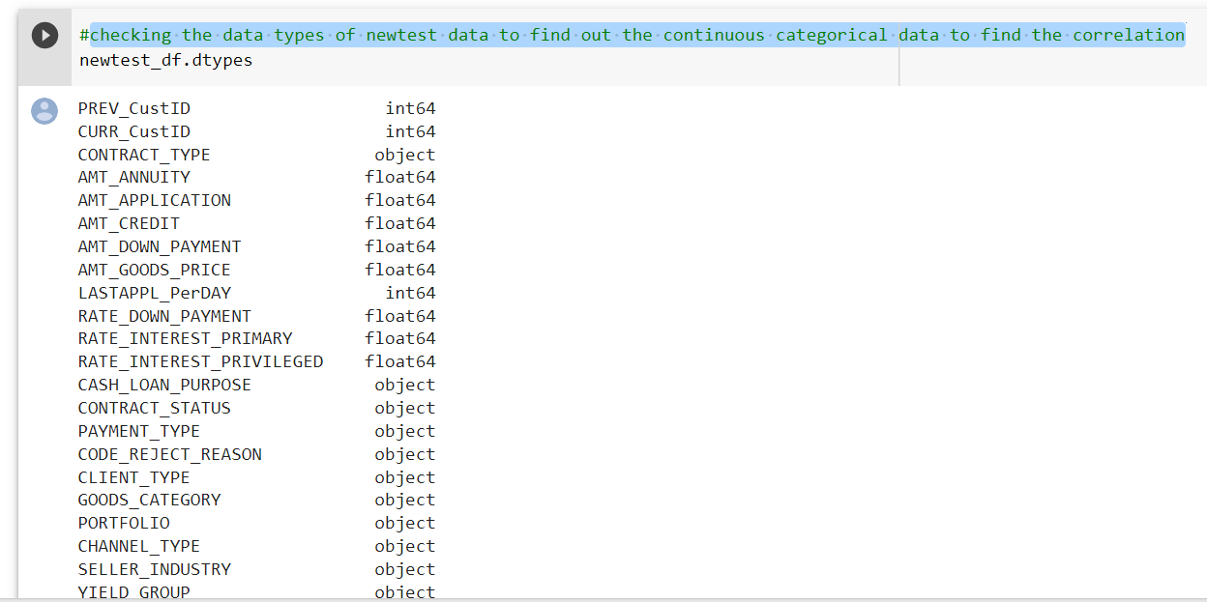

taking only continuous data into account

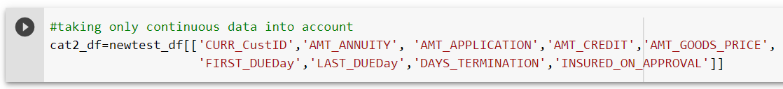

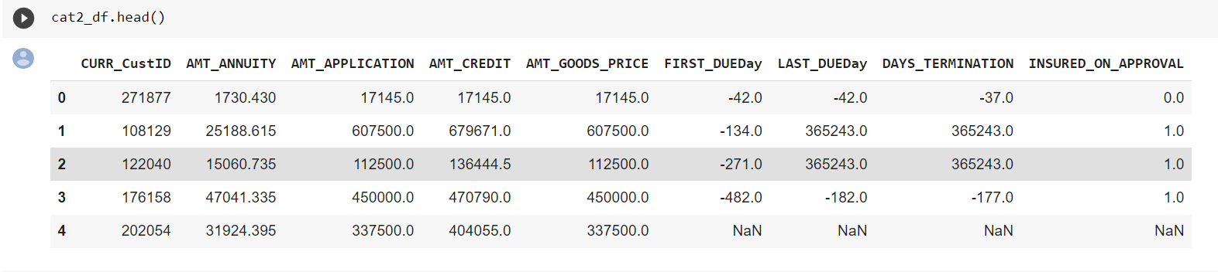

Checking Corrilation Between columns of numeric continues data

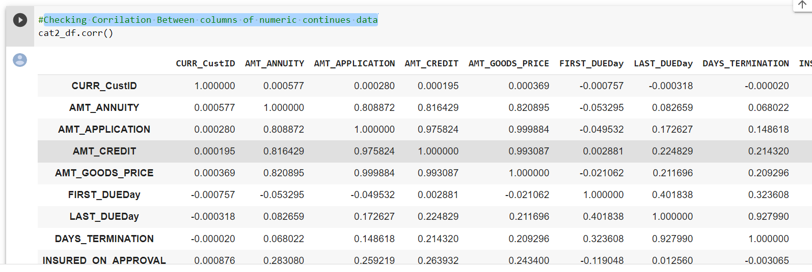

dropping the columns having null vvalues and creating new dataframe

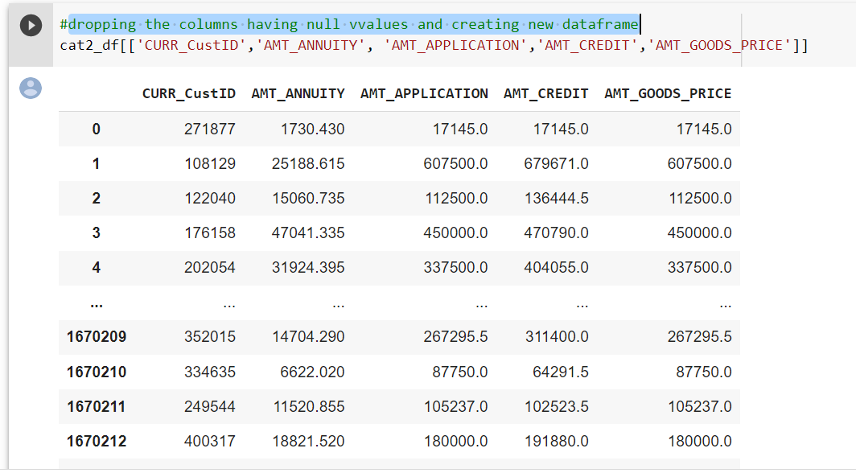

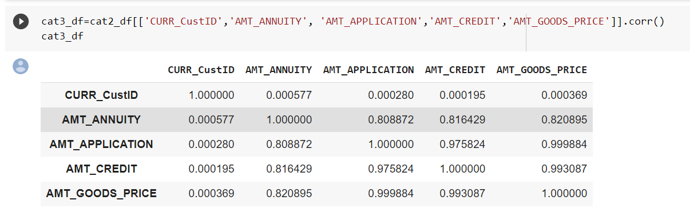

Conclusion-->

1. AMT_ANNUITY is strongly correlated with

* AMT_APPLICATION by corelation coefficient 0.808872
* AMT_CREDIT by corelation coefficient 0.816429
* AMT_GOODS_PRICE by corelation coefficient 0.820895

1. AMT_APPLICATION is strongly correlated with

* AMT_CREDIT by corelation coefficient 0.975824
* AMT_GOODS_PRICE by corelation coefficient 0.999884

1. AMT_CREDIT is strongly correlated with

* AMT_GOODS_PRICE by corelation coefficient 0.993087

# ploting pairplot for continues data to check the retaion between columns

creating pairplot graph

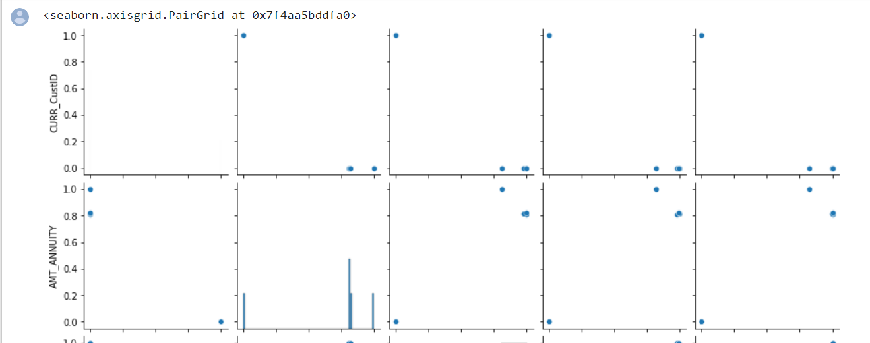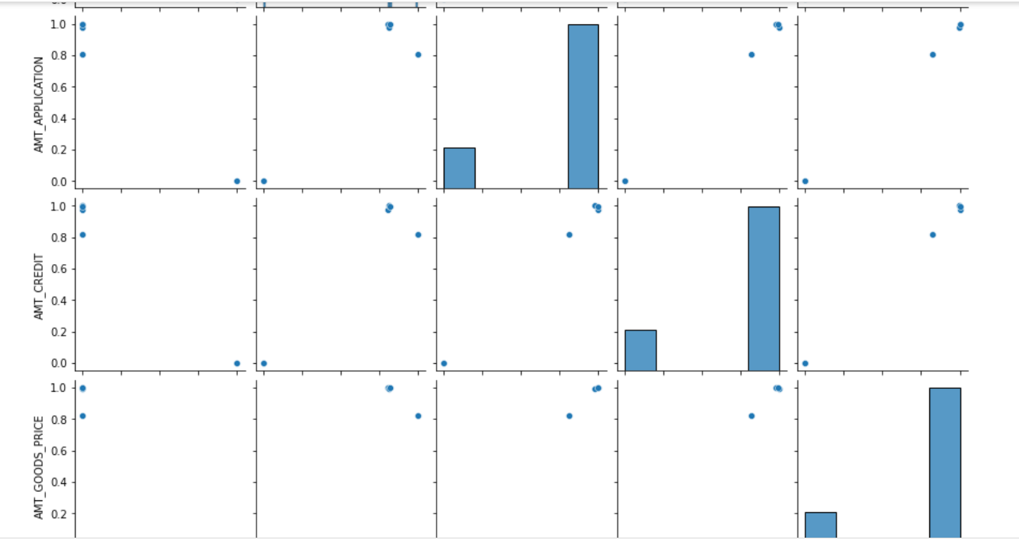



Conclusion:

# Handling Outliers

Checking outliers for INCOME

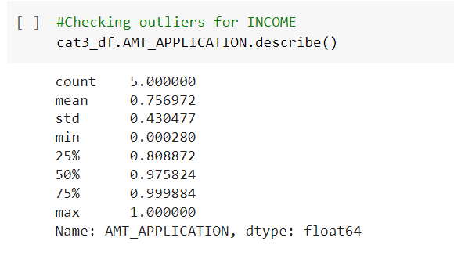

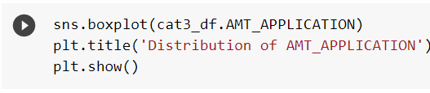

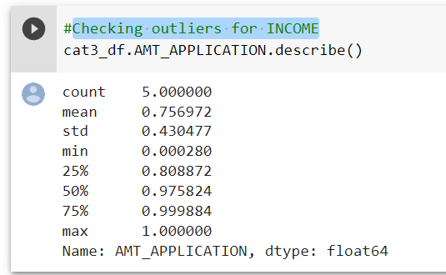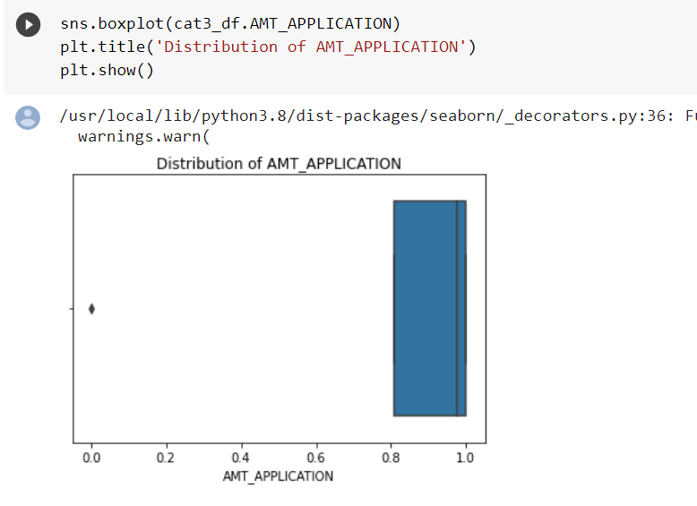

Conclusion:

AMT_CREDIT

Checking outliers for AMT_CREDIT

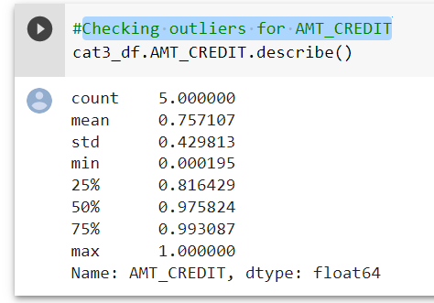

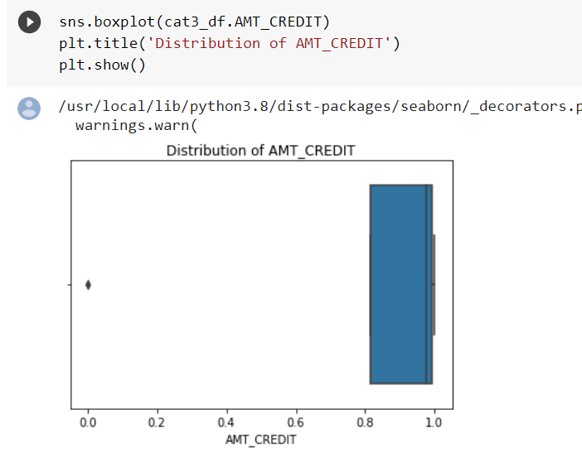

Conclusion:

AMT_GOODS_PRICE

Checking outliers for AMT_GOODS_PRICE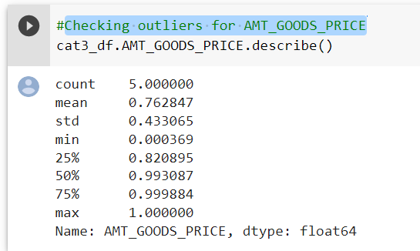

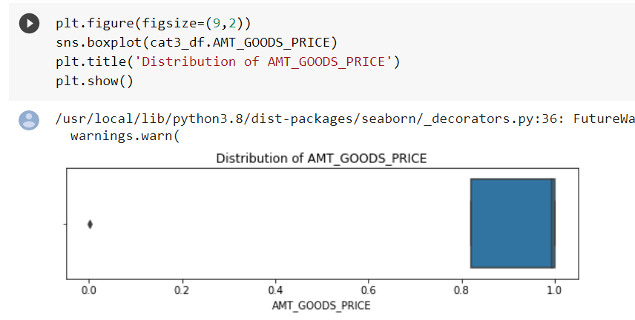

**Conclusion:**

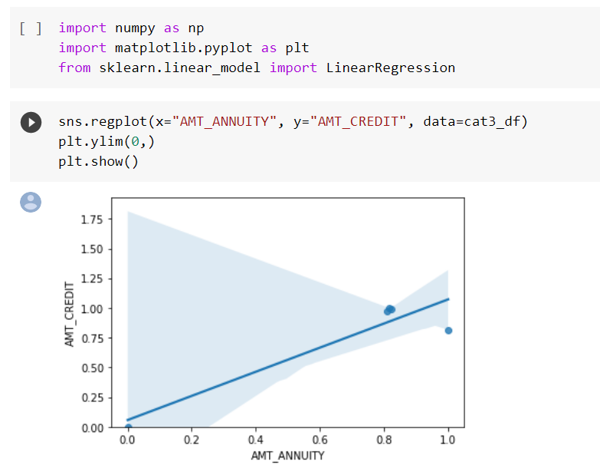

**Conclusion:**

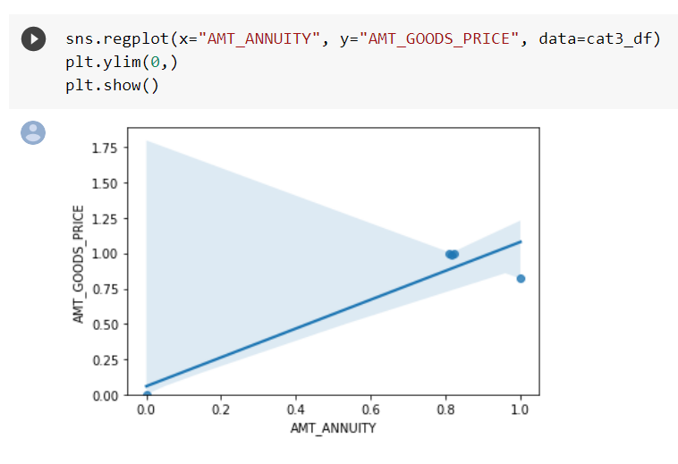

**Conclusion:**

**Filtering data on bases of Loan amount for top 10 loan amounts**

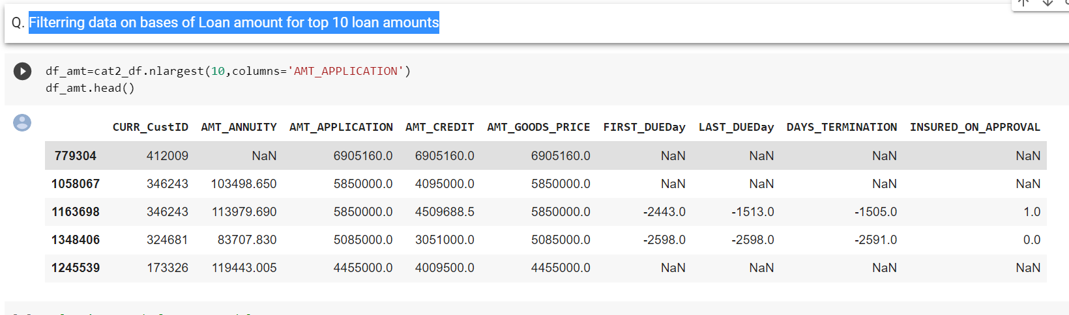

Plotting graph for approved loan amount 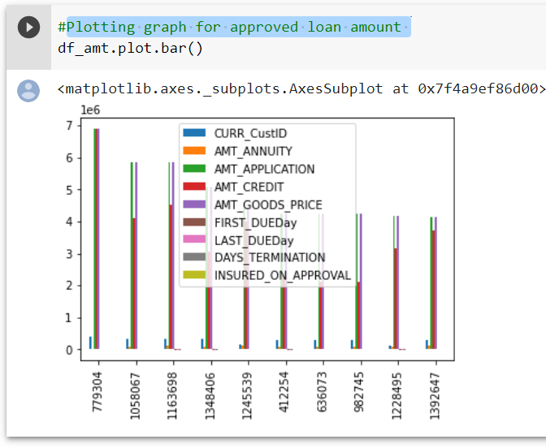

conclusion: